Jaeyoung Sung, 성재영 |  | 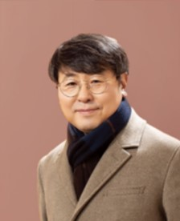
Professor
Department of Chemistry
Chung-Ang University
Korea
E-Mail: jaeyoung@cau.ac.kr
1997: | Ph. D, Seoul National University, Korea
1998 – 2000: | Post doc, Korea University, Korea
2000 – 2003: | Post doc, Massachusetts Institute of Technology, USA
2004 – Present: | Professor, Chung-Ang University

Chemical Dynamics in Living Cells

We will introduce new chemical dynamics models and theories useful for a quantitative investigation into chemical dynamics in living cells [1,2]. Our primary focus will be on the chemical fluctuation theorem (CFT) governing gene expression and its application to quantitative explanations of stochastic gene expression and signal propagation dynamics in and across living cells. In addition, we will talk about our newly developed transport equation [3], whose solution provides quantitative understanding of thermal motion of molecules and ions in various complex fluids and solid electrolytes. If time permits, we will also talk about our recent work on nuclei seeds formation and phase transition dynamics. This work sheds light on the thermodynamic origin of stable nuclei formation and provide unified, quantitative explanation of the size distribution and size-dependent growth rate of various nanoparticles and biological condensates.

References:
[1] Park et al., Nature Communications 9, 297 (2018); Lim e al., Phys. Rev. X 5, 031014 (2015).
[2] Song et al., PLoS Computational Biology 15, e1007356 (2019); Kang et al., Nature Communications 13, 6506 (2022).
[3] Song et al., Proc. Nat. Acad. Scie. U.S.A. 116, 12733 (2019); Poletayev et al., Nat. Mater. 21, 1066 (2022).

