Toru Kondo |  | 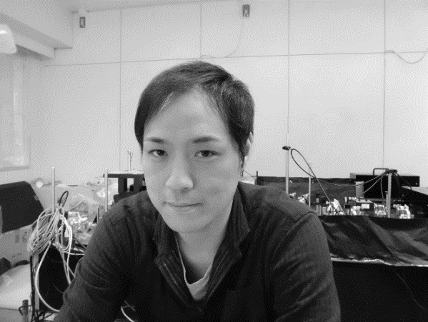
Professor
Division of Photophysical Biology
National Institute for Basic Biology
Japan
E-Mail: tkondo@bio.titech.ac.jp
2011 : | Ph. D, Nagoya University, Japan
2011 – 2015: | Post doc, Tokyo Institute of Technology, Japan
2015 – 2018: | Post doc, Massachusetts Institute of Technology, USA
2018 – 2020: | Assistant Professor, Tohoku University, Japan
2020 – 2024: | Lecturer, Tokyo Institute of Technology, Japan
2024 – Present: | Professor, National Institute for Basic Biology, Japan

Single-molecule spectroscopy of photosynthetic systems.
Photosynthetic photoreaction is regulated in pigment-protein complexes. As structural analysis techniques have advanced, protein structures have been elucidated at the atomic level, allowing for discussions of photoreaction mechanisms based on detailed structural information. In particular, theoretical calculations considering molecular coordinates enable the interpretation of spectroscopic data and the construction of photoreaction models. Through these efforts, we understand that the molecular arrangements and optical properties of each pigment embedded in proteins are highly optimized. However, it is also known that the protein scaffold is unstable, i.e., its conformation undergoes thermal fluctuations and changes in response to photoreactions. Therefore, we face a significant question of how the photosynthetic photoreaction is optimized even in such dynamic and inhomogeneous environments. To address this question, we apply the single-molecule spectroscopy for elucidating the contributions of protein conformational dynamics and inhomogeneities to the photoreaction process. Analyses of temporal fluctuations in the fluorescence intensity, lifetime, and spectrum revealed switching behaviors of the energy transport pathway in the photosynthetic protein [1-3]. Combining optical microscopy with ultrafast spectroscopy enabled direct observation of energy transfer in a single photosynthetic protein and light-harvesting antenna, providing insights into how microscopic conformational perturbations affect ultrafast photochemical reactions in biological systems.
References
[1] T. Kondo, J. B. Gordon, A. Pinnola, L. Dall’Osto, R. Bassi, and G. S. Schlau-Cohen, Proc. Natl. Acad. Sci. U.S.A. 2019, 116, 11247.
[2] T. Kondo, R. Mutoh, H. Tabe, G. Kurisu, H. Oh-Oka, S. Fujiyoshi, and M. Matsushita, J. Phys. Chem. Lett. 2020, 11, 3980.
[3] T. Kondo, R. Mutoh, S. Arai, G. Kurisu, H. Oh-Oka, S. Fujiyoshi, and M. Matsushita, J. Chem. Phys. 2022, 156, 105102.

